Assignment_1 Report (TensorFlow, Keras, Keras_CNN)
Dataset: - A_Z Handwritten Data
Student Name & ID: - Preeti Yadav (999904549)
Instructor Name: - Dr. Al Shami
Submission Date: - June’29, 2026

Introduction- The objective of this assignment is to build and compare three deep learning models for handwritten alphabet recognition using the A–Z Handwritten Alphabet dataset. The models include a TensorFlow Artificial Neural Network (ANN), a Keras Artificial Neural Network (ANN), and a Keras Convolutional Neural Network (CNN). Their performance was evaluated using test accuracy, classification reports, and confusion matrices.
TensorFlow ANN Model
Data Preprocessing:
I have loaded A–Z Handwritten Alphabet dataset CSV file using the Pandas library. Separated first column, containing the alphabet labels (0–25), from the remaining 784-pixel values representing each handwritten image. Converted image data to the float32 data type and normalized by dividing the pixel values by 255, scaling them to the range of 0–1. Then I splitted dataset into 80% training and 20% testing sets using train_test_split(). Since the TensorFlow ANN accepts one-dimensional input, each image was represented as a flattened vector of 784 input features. Integer class labels were retained because I used Sparse Categorical Crossentropy loss function during training in the model.
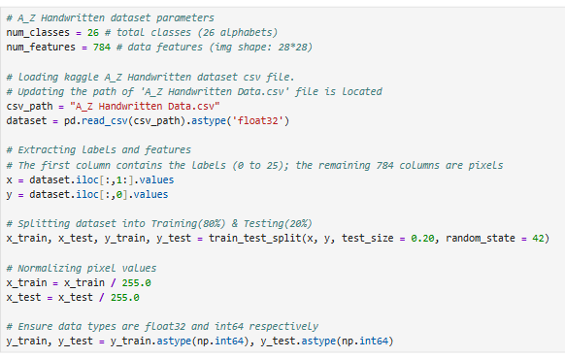
Model Architecture:
This model consists of 784 input neurons, corresponding to the 784 pixels of each handwritten image, followed by two hidden layers containing ReLU activation function. The output layer contains 26 neurons, and uses the SoftMax activation function for multi-class classification. The model is trained using the Adam optimizer with the Sparse Categorical Crossentropy loss function.

- Input layer: 784 neurons
- Hidden layer 1: 512 neurons (ReLU)
- Hidden layer 2: 256 neurons (ReLU)
- Output layer: 26 neurons (Softmax)
- Optimizer: Adam
- Loss Function: Sparse Categorical Crossentropy
Training & Hyperparameters:
- Learning rate: 0.001
- Batch size: 128
- Training steps: 5000
- Optimizer: Adam

Result Evaluation:
- Test Accuracy is 98.06%
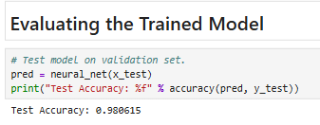

- Classification Report:
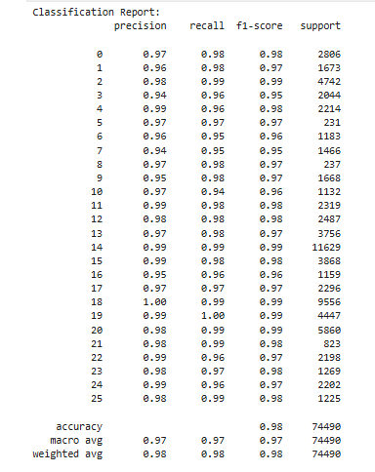

- Confusion Matrix:
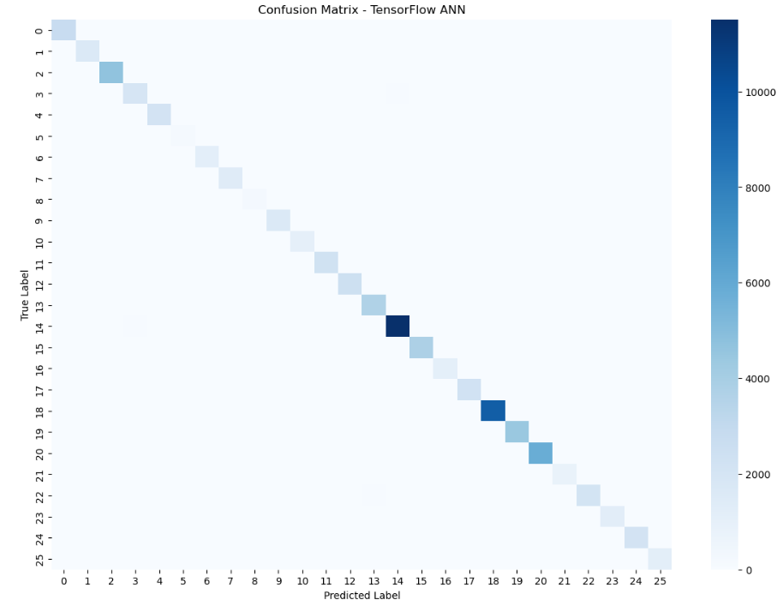

Findings: TensorFlow ANN model achieved approximately 98.06% test accuracy. The classification report showed high precision, recall, and F1-scores across most classes. The confusion matrix indicated only a small number of misclassifications.
Keras ANN Model
Data Preprocessing-
I have loaded A–Z Handwritten Alphabet dataset using the Pandas library and divided into image features and class labels. Then converted image data to the float32 data type and normalized by dividing each pixel value by 255, resulting in values between 0 and 1. Then, Splitted dataset into 80% training and 20% testing sets using train_test_split(). Each handwritten image was flattened into a 784-dimensional feature vector, making it suitable for the Artificial Neural Network. Converted class labels into one-hot encoded vectors containing 26 classes (A–Z) to support multi-class classification using the Categorical Crossentropy loss function.
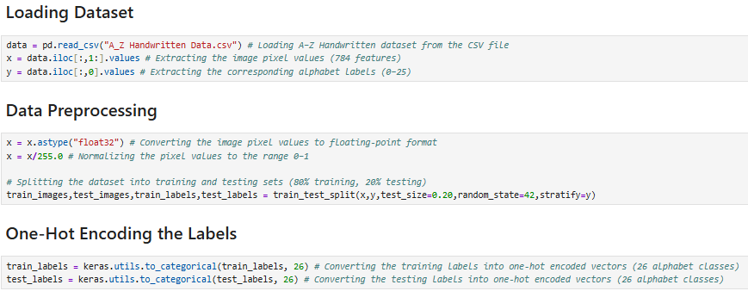
Model Architecture:
This Model consists of an input layer with 784 neurons, corresponding to the 784 pixels of each handwritten image, followed by one hidden layer with 512 neurons using the ReLU activation function. A Dropout layer (30%) is included to reduce overfitting during training. The output layer contains 26 neurons, representing the 26 alphabet classes (A–Z), and uses the Softmax activation function for multi-class classification. The model is trained using the RMSprop optimizer with the Categorical Crossentropy loss function.

- Input: 784
- Hidden Layer: 512 neurons (ReLU)
- Dropout
- Output: 26 classes (Softmax)
- Optimizer: RMSprop

Training & Hyperparameters: -
- Batch size: 128
- Epochs: 15
- Validation split: 10%
- Optimizer: RMSprop

Result Evaluation: -
- Test Accuracy is 98.58%
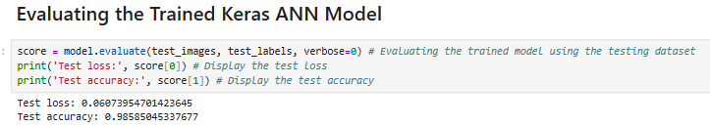

- Classification Report:
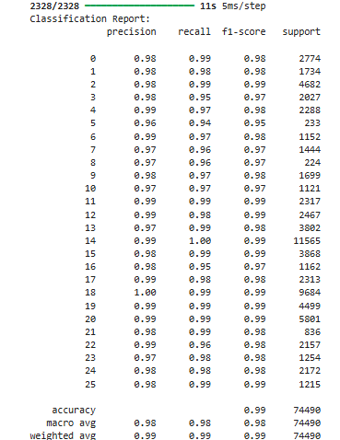

- Confusion Matrix:
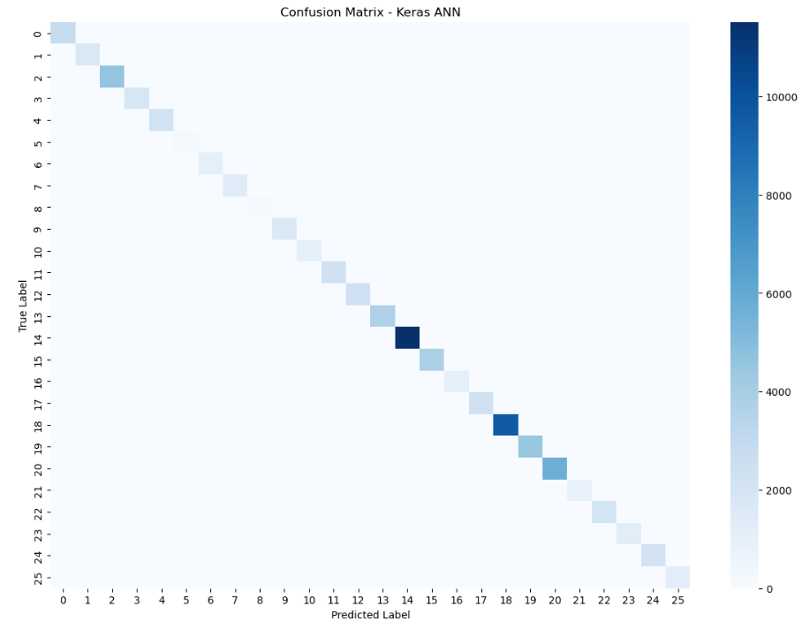

Findings: Keras ANN achieved approximately 98.58% test accuracy. The evaluation metrics and confusion matrix demonstrated strong and consistent classification performance across the alphabet classes.

Keras CNN Model

Data Preprocessing:
Loaded A–Z Handwritten Alphabet dataset from a CSV file using Pandas, with the first column containing the alphabet labels and the remaining columns representing the pixel values of each handwritten image. Converted image data to the float32 data type and normalized by dividing the pixel values by 255, scaling them to the range of 0–1. After splitting the dataset into 80% training and 20% testing sets, each image was reshaped into 28 × 28 × 1 format to preserve its spatial information for the Convolutional Neural Network. Finally, converted class labels into one-hot encoded vectors with 26 output classes, enabling multi-class classification using the Categorical Crossentropy loss function.
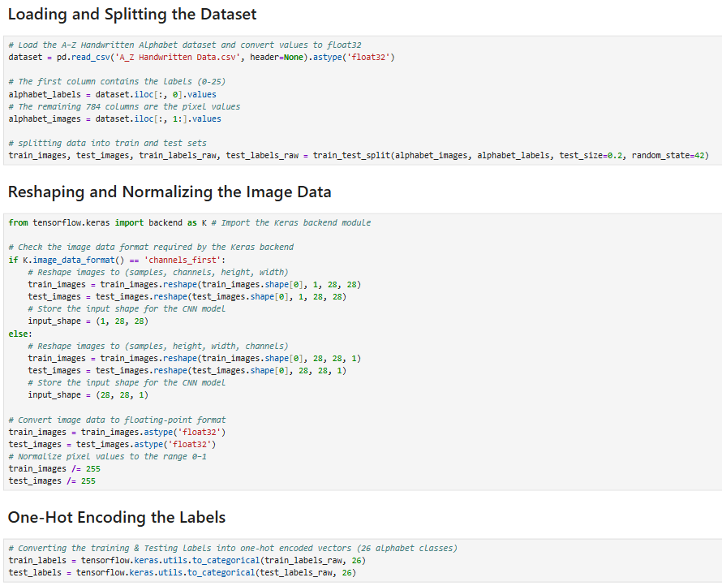
Model Architecture:
This Model consists of two convolutional layers with 32 and 64 filters, respectively, both using the ReLU activation function to extract spatial features from handwritten alphabet images. These are followed by a Max Pooling layer to reduce the feature map dimensions and a Dropout layer (25%) to minimize overfitting. The extracted features are then flattened and passed through a fully connected dense layer with 128 neurons using ReLU activation, followed by another Dropout layer (50%). Finally, the output layer contains 26 neurons with the Softmax activation function to classify the handwritten images into the 26 alphabet classes (A–Z). The model is trained using the Adam optimizer with the Categorical Crossentropy loss function.

- Conv2D (32 filters)
- Conv2D (64 filters)
- MaxPooling2D
- Dropout (0.25)
- Flatten
- Dense (128, ReLU)
- Dropout (0.5)
- Dense (26, Softmax)
- Optimizer: Adam
- Loss function: Categorical Crossentropy

Training & Hyperparameters:
- Batch size: 50
- Epochs: 5
- Optimizer: Adam

Result Evaluation:
- Test Accuracy is 98.95%
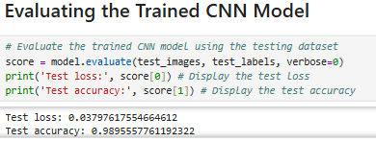

- Classification Report:
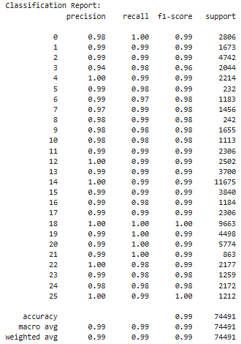
- Confusion Matrix:
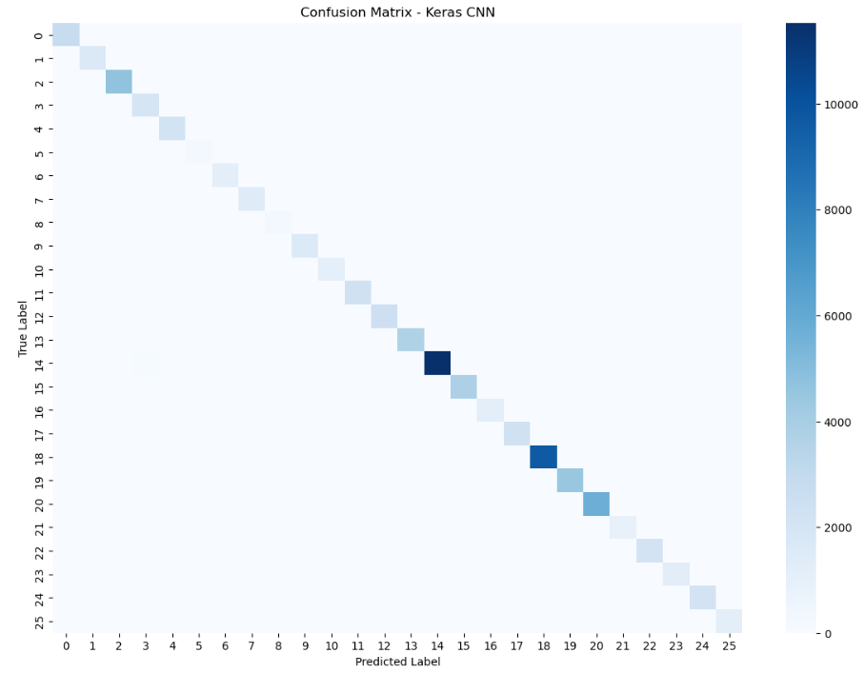

Findings: Keras CNN achieved the highest performance with approximately 99.00% test accuracy. The classification report and confusion matrix confirmed excellent classification accuracy with very few misclassifications.

Comparison of Models:
Model | Test Accuracy | Observation
TensorFlow ANN | 98.06% | Good baseline model with high accuracy
Keras ANN | 98.58% | Improved accuracy with simpler implementation
Keras CNN | 98.95% | Highest accuracy and best overall performance

Discussion:

Challenges:
Selecting appropriate model architecture and training parameter (e.g.- no. of hidden layers, training epochs, batch size along with correct optimizer) while ensuring that model should give good performance without overfitting or underfitting.

Limitations:
Since I have trained & evaluated all three models using A_Z Handwritten Dataset so model performance may vary for different dataset or unseen dataset.

Potential Improvements:
For further improvement in classification performance and model generalization, other architectures like batch normalization, early stopping or learning rate scheduling can be use.

Conclusion:
Three deep learning models were implemented and evaluated using the A–Z Handwritten Alphabet dataset. The TensorFlow ANN and Keras ANN achieved high classification accuracy, while the Keras CNN provided the best overall performance with approximately 99% test accuracy. The evaluation metrics and confusion matrices demonstrate that CNNs are more effective for handwritten image classification because they automatically learn important spatial features from the images.

References
- TensorFlow Documentation. https://www.tensorflow.org/
- Keras Documentation. https://keras.io/
- TensorFlow Keras API Documentation. https://www.tensorflow.org/api_docs/python/tf/keras

